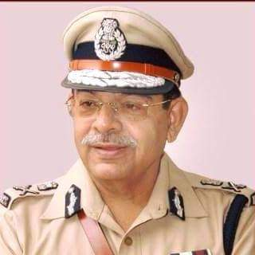

I wish to record my appreciation of every aspect of your college including its infrastructure, vast variety of activities, its ambience and education friendly environment. The college has adopted latest teaching skills and technology which is admirable. I got to react with the students and found their responses intelligent. I also congratulate you for your new website and I'm sure that this website will enable all the students to take full advantage of the IT highway which in turn will take your college to new heights.
I wish the college success in both indoors and outdoors, in character building and producing highly informed citizens who will benefit the society, the state and the nation.

